12th MIDWEST CYSTINOSIS GATHERING
August 2001

The 12th Midwest Cystinosis Gathering was held August 3rd-5th, 2001 in Sioux City, Iowa with Lonnie and Joan Hohl as hosts. The Hohl’s daughter, Keri, who has cystinosis, is now 14 years old, and her sister, Kasey w/out is 10 years old. The gathering was held at Sioux City’s Comfort Inn on South Lakeport where a block of rooms had been reserved for the 7 families that attended. In attendance were: Eric and Dena Gard w/ their children, Mikaela age 8 w/ and Nikolas age 9 w/out (from Casey, Illinois); Robert and Sylvia Douglas with 2 of their 4 children, Amelia age 15 w/ and Ian age 10 w/out (from Kirksville, Missouri); Darlis and Bill Croce along with their adult children, Keith age w/ and Bill age w/ (from Maquoketa, Iowa); Don and Doretta Hoffman and children, Andrew age 13 w/ and Jon age 17 w/out (from Story City, Iowa); Don and Candy Wagner and children, Nick age 17 w/ and Gabe age 19 w/out (from Burlington, Iowa); Larry and Carolyn Egger and their granddaughter, Julia Baxter age 16 w/ (from Letts, Iowa); and Lonnie and Joan Hohl with their children. We had a formal meeting time on Saturday morning, a cookout on Saturday night and discussed a range of topics throughout the weekend. We decided one could tell our families were becoming comfortable with each other as laughter, teasing and joking was part of the fun! Plans are already being put together for the summer of 2002, as potential dates are: August 2nd-4th and the location being considered is Springfield, Illinois with Dena and Eric Gard as the hosts.

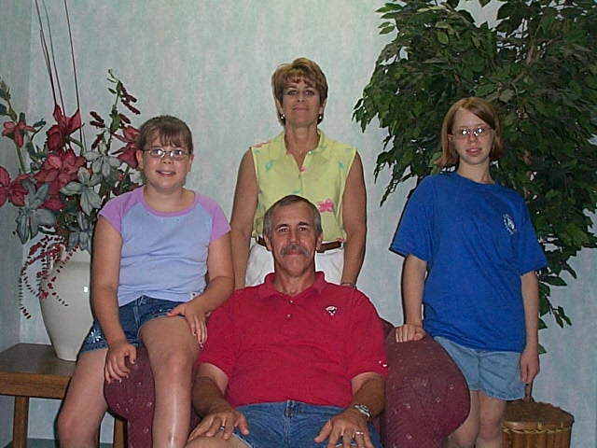

Family members with Cystinosis The Hohls (gathering leaders)

